FROM ANT TO EAGLE NAME: __________________________
MY SECRET SPOT!
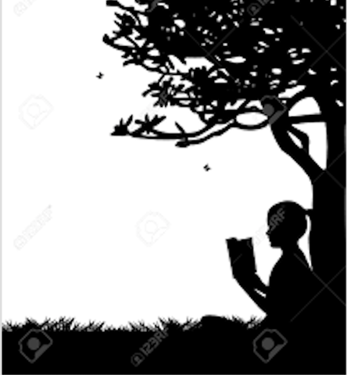
In From Ant to Eagle, Cal and Aleta find a Secret Spot with a quiet pond and shady reading trees. There is also a mud-slide, a rope swing and a beautiful view of Lake Huron. If you had a secret spot of your own, what would it look like? Where would it be? Draw a picture or map of your perfect Secret Spot, or if you prefer, draw a picture of Cal and Aleta’s. Whatever it looks like, you decide…
__________________________________________________________

