A Letter From Alex Lyttle

Dear Reader,

I am the author of From Ant To Eagle, as well as a pediatrician — which is a doctor who looks after children. If you have just finished reading my book, you might be thinking, “Man, what a total downer. Why was that book so depressing?” And you’re right, it is a sad book. But I think it also has an important message. By reading about Sammy from the perspective of his brother, Cal, it allows you to see what he and his brother are going through. My hope was that this would then allow you to empathize with him, or put yourself in his position.

How did it make you feel? Did you wish that you could help Sammy? Perhaps you’ve thought about one day becoming a doctor so you could help children like Sammy. If so, I’ve created some activities to help you get there. There’s a few things to do, like figuring out how to get out of a maze, answering some super-duper, incredibly hard doctor questions and having a steady hand to colour the cover of my book.

The questions are meant to be REALLY hard! Please don't get frustrated if you don't know the answers. If you manage to get even one correct, you're probably a genius. But no matter how well you do, it’s important to know that you don’t have to be a doctor to help someone who isn’t feeling well.

Just as Cal helped Sammy feel better by giving him the Levels, you can help others feel better just by showing them you care. Whether it’s a hug or a card, don’t forget to let people know you are thinking of them, because the most powerful medicine in the world is kindness.

Thank you for reading my book. I hope you liked it!

Sincerely,

Dr. Alex Lyttle

Colour the Cover the Way You Want!
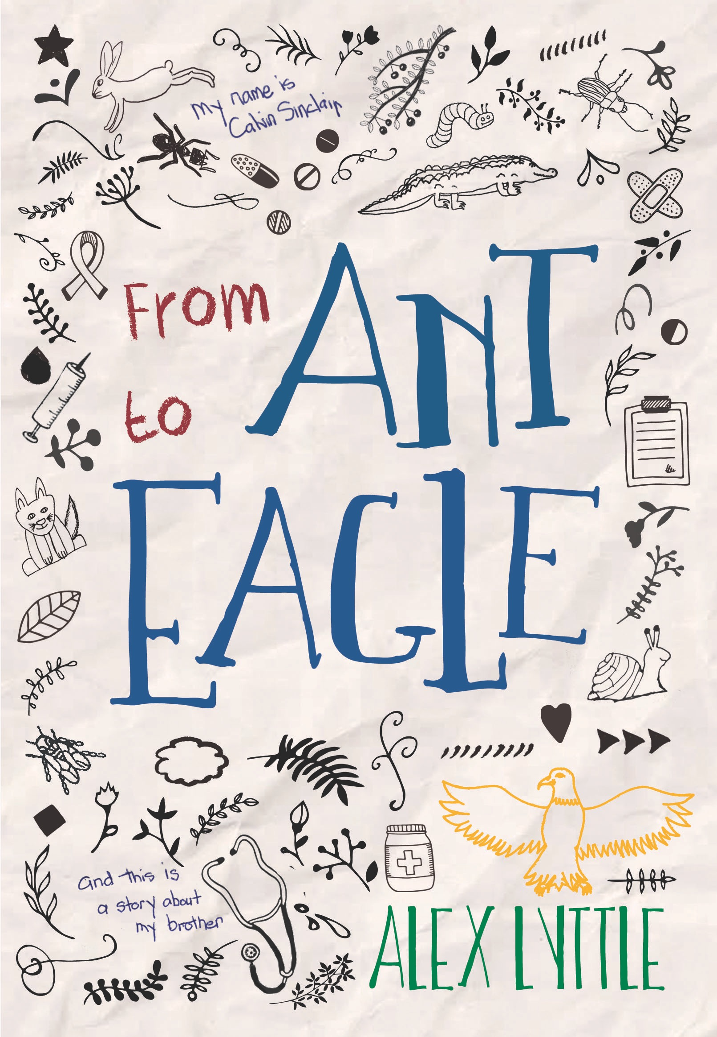
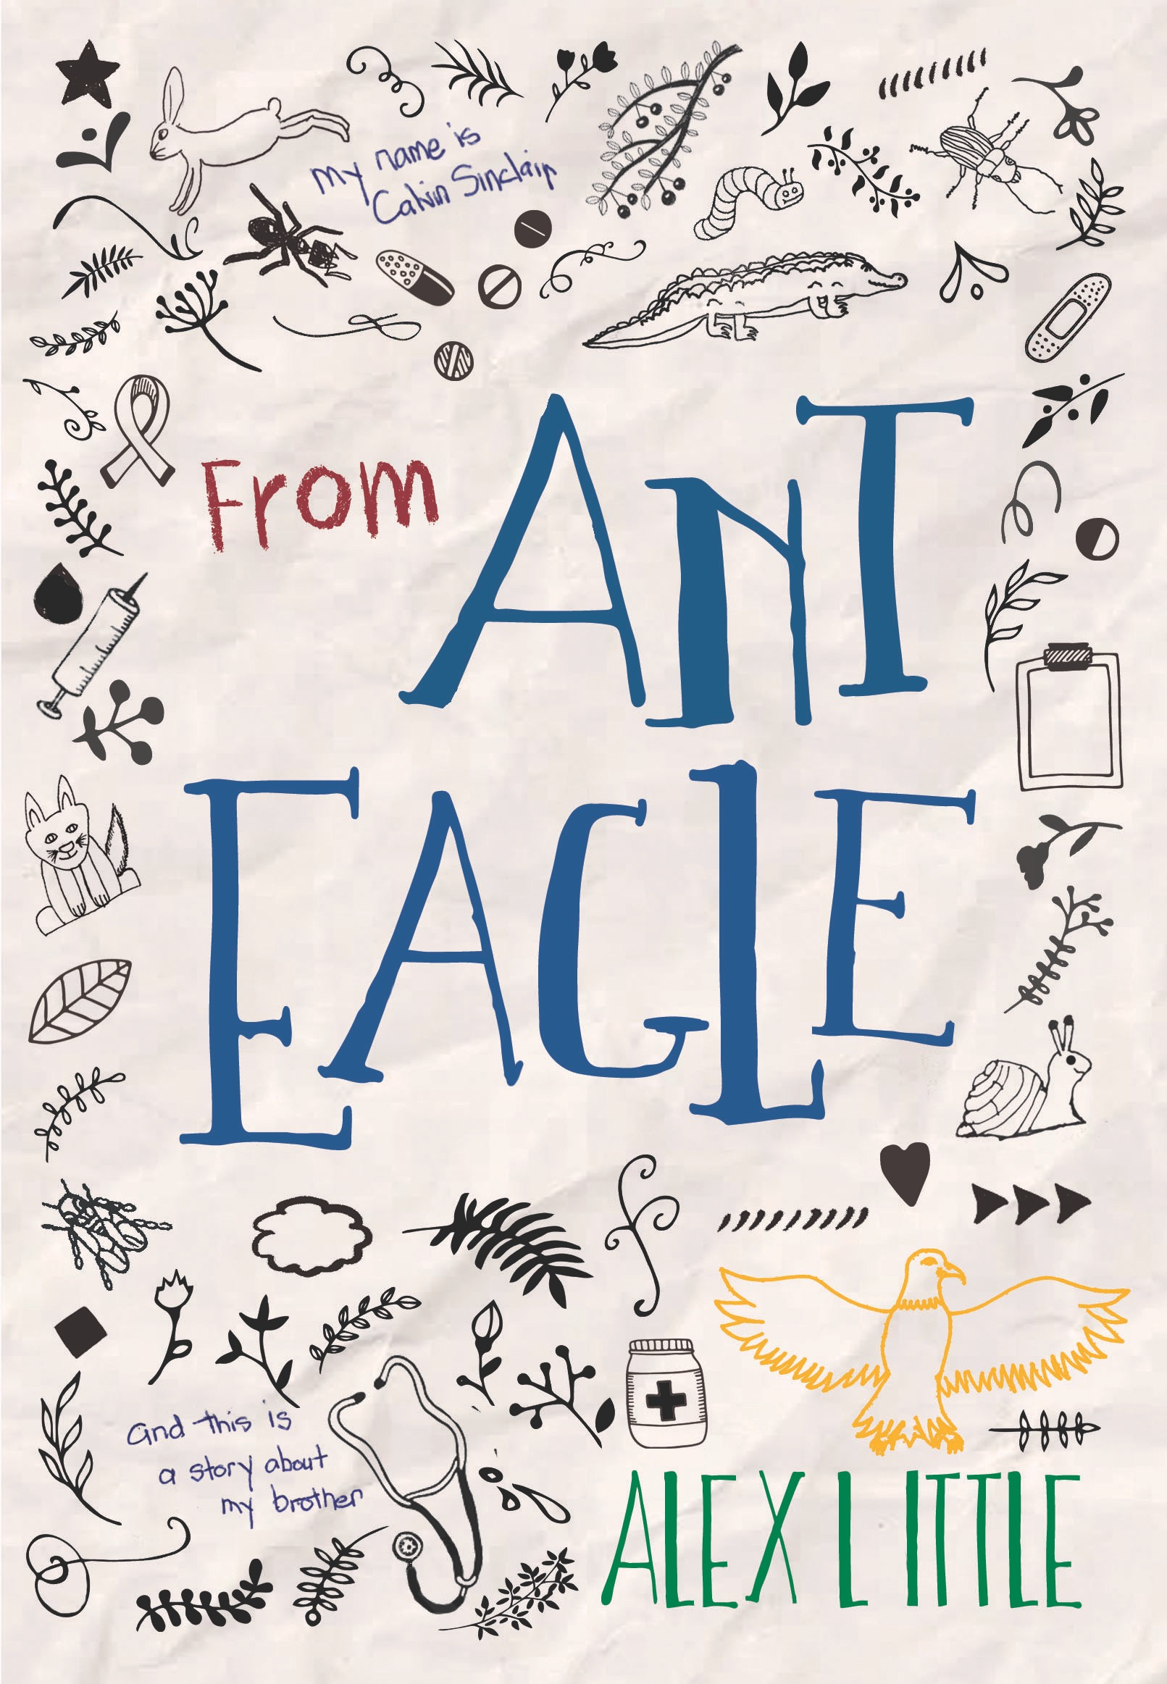
Spot the Difference! - Find 8 Things that are
Help Ant Become an Eagle!
Can you find the way out?
Are You Ready To Be A Doctor?

1. In From Ant To Eagle, Sammy gets cancer. Which of the following is true about a person with cancer?
a) Their body doesn’t make enough insulin.
b) Their airways get tight when they run and they sometimes need medicine to help them breathe.
c) They have a cell in their body that starts to split and grow into more and more cells that can eventually take over their body.
d) Instead of having feet they have a tail like a fish and live underwater.

2. True or False: Most children who get cancer can be cured.

3. Cal says that before Sammy got sick, the worst thing he’d seen on the playground was a broken arm. What is it called when you break your arm so badly that the bone sticks out of the skin?
a) A compound fracture
b) A greenstick fracture
c) A bone-through-the-skin fracture
d) Sorry, I can’t answer this question, I just fainted

4. Sammy has a seizure on the playground. The best thing you can do if you see someone having a seizure is:
a) Stick something between their teeth so they don’t accidentally bite their tongue
b) Try to wake them up
c) Splash water on their face
d) Move everything around them so they don’t accidentally kick something and call for help

5. As an allergist, I had to throw this question in: Which of the following is NOT a common allergy?
a) Peanuts
b) Bees
c) Medicine
d) Water
6. Sammy gets pneumonia. This means that he had an infection in his:
a) Heart
b) Brain
c) Lungs
d) Skin

7. Speaking of cancer, the best way to prevent skin cancer is to:
a) Eats lots of vegetables
b) Drink lots of water
c) Wear sunscreen
d) Wash your body with strawberry jam instead of soap

8. In one part of the novel, Cal is worried that Sammy is depressed. When someone is depressed they are feeling very:
a) Sad
b) Happy
c) Angry
d) Gassy

9. Here’s an interesting bit of trivia: If someone has epistaxis, this means they:
a) Have the hiccups
b) Can’t eat gluten
c) Are afraid of the dark
d) Have a nosebleed

10. What kind of doctor looks after the elderly? (Note: The elderly means ‘old people’, but it’s nicer to call them elderly… or very mature…)
a) Pediatrician
b) Geriatrician
c) Cardiologist
d) Respirologist

Answers

Question 1:
a) FALSE – This answer is diabetes. In diabetes a person’s body doesn’t make enough insulin. Normally insulin helps lower the sugar in our blood. Someone with diabetes needs to take insulin by a needle or pump so that there isn’t too much sugar in their blood.
b) FALSE – This is asthma, one of the most common childhood illnesses. Children with asthma sometimes have trouble breathing when they get a cold or run really fast. When this happens, they take a medicine through a puffer to help open their airways.
c) TRUE – Cancer is a problem where one cell starts to replicate over and over. It makes so many cells that it can hurt the body.
d) FALSE – This is a mermaid. If you guessed this, you probably need to study a bit more before you become a doctor.

Question 2:
TRUE!!! Over 90% of children with cancer are cured. So then why didn’t Sammy get cured? Unfortunately, some children can’t be cured. And while it would have been a happier book if Sammy had lived, I wanted to show people what it would be like if he didn’t.

Question 3:
a) True – A compound fracture is one where the bone comes through the skin.
b) False – This is a common type of fracture in children where the bone bends before it breaks. This happens because children’s bones are softer than adults.
c) False – This would be a really easy name to remember but unfortunately isn’t correct.
d) If you fainted from reading this answer you probably had something called a vaso-vagal episode. This can happen to some people when they see blood or hear about something gross.

Question 4:
a) False – This is a myth. Don’t do this. If you put something in someone’s mouth when they are having a seizure they could choke on it.
b) False - If you get too close you might get kicked. It’s better to stay back.
c) False – Don’t do this. It won’t work. And they will probably not be happy when they wake up.
d) True – These are the most important things to do when someone is having a seizure. Most seizures stop on their own but it’s important to call for help.

Question 5:
a) False – Peanuts ARE a common allergy. About 1-3% of children have a peanut allergy.
b) False – Bees along with wasps, hornets and yellow jackets are called hymenoptera. These ARE relatively common allergies.
c) False – Lots of people are allergic to penicillin and other types of medications.
d) True – This is not a common allergy. Some people have what is called aquagenic urticaria, a condition where they get hives when they touch water, but this is not very common.

Question 6:
a) False – An infection of the heart is called myocarditis.
b) False – An infection of the brain is called meningitis.
c) True
d) False – An infection of the skin is called cellulitis.

Question 7
a) False – While this is healthy, it is not the best way to prevent skin cancer.
b) False – Again, healthy but not the right answer.
c) True – Sunscreen is a very good way to prevent skin cancer.
d) False – This just seems like a bad idea all around.

Question 8
a) True – When someone has depression they are often too sad to do the things they usually like to do. If you are ever feeling really sad, the best things you can do are 1. Tell an adult. 2. Exercise and 3. Eat healthy!
b) False
c) False
d) False

Question 9
a) False – The medical term for hiccups is “Singultus”
b) False – People with celiac disease can’t eat gluten which is a protein in wheat
c) False – The fear of the dark is called nyctophobia
d) True – This is the medical term for nosebleed

Question 10
a) False – This is a doctor for children.
b) True
c) False – This is a doctor that looks after the heart.
d) False – This is a doctor that looks after the lungs.

Spot the Difference
- The Bunny only has one ear
- There is only one bandage instead of two.
- The “to” is missing in the title.
- The Chart is missing its writing
- The Snail has an eye.
- Lyttle is spelled Little.
- The cross on the Pill Bottle is filled in.
- The Eagle’s head is pointing to the right instead of the left.

